Exploring Wardriving and Its Legal Implications
Course: ITC 4610 Penetration Testing
Prepared by: Mandip Amgain
Date: February 23, 2026
Professor: Betty J. Lauer

Introduction
Wireless networking has become essential in modern society. Wi-Fi networks are deployed in homes, campuses, businesses, and public spaces. Because wireless networks broadcast radio signals, they can be detected by nearby devices. The practice of identifying and logging wireless networks while moving through an area is known as wardriving.
This report explores wardriving from technical, legal, and ethical perspectives. It also includes supervised practical wardriving activity using wireless scanning software in a public area. The purpose is educational: to understand how wireless networks are detected and to analyze common security configurations without attempting unauthorized access.

Part 1 : Research on Wardriving
What is Wardriving?
Wardriving is the act of searching for Wi-Fi wireless networks using a laptop or mobile device while moving through an area. The term was inspired by the movie WarGames, where a character scans telephone numbers for connected modems.
Definition
Wardriving involves passively scanning for wireless networks and collecting publicly broadcast information such as:
- SSID (Network Name)
- Signal strength (RSSI)
- Security protocol (WEP, WPA, WPA2, WPA3)
- Channel number
- MAC address (BSSID)
Importantly, wardriving does not require connecting to networks. It only detects beacon signals that routers broadcast automatically.

Why is Wardriving Performed?
Ethical Uses
- Wireless coverage analysis
- Security auditing
- Academic research
- Identifying misconfigured networks
- Mapping public Wi-Fi availability
Unethical Uses
- Finding open networks for unauthorized access
- Identifying weak encryption
- Intercepting unencrypted traffic

Wardriving vs. Wardracking
- Wardriving – Digitally detecting and logging wireless networks.
- Wardracking – Physically marking discovered open Wi-Fi networks in public areas using symbols.
Wardracking is mostly historical; wardriving is the modern digital approach.

Wardriving Tools
1. Vistumbler
Vistumbler
- Windows-based Wi-Fi scanner
- Uses Windows Native Wi-Fi API
- Displays SSID, signal strength, encryption
- Supports GPS logging
- Exports results to CSV
2. Kismet
Kismet
- Open-source tool
- Passive network detection
- Detects hidden networks
- Advanced wireless analysis
3. NetStumbler
NetStumbler
- Older Windows scanner
- Active probing method
4. Wireshark
Wireshark
- Packet analyzer
- Used for deeper traffic inspection

How These Tools Work
Wireless access points continuously broadcast beacon frames that include:
- SSID
- Encryption type
- Channel
- Capabilities
Wardriving software listens to these broadcasts and logs them. No authentication is required to detect this information.

Part 2 : Legal and Ethical Aspects
Legal Status of Wardriving
United States
Detecting publicly broadcast Wi-Fi signals is generally legal. However, unauthorized access is illegal under:
Computer Fraud and Abuse Act
The CFAA prohibits:
- Accessing networks without authorization
- Exceeding authorized access
- Data theft
Even connecting to an open network without permission can result in legal consequences.

European Union
The General Data Protection Regulation (GDPR) regulates data privacy. Collecting personally identifiable data may violate privacy laws.
EU cybercrime directives also criminalize unauthorized access to systems.

Ethical Concerns
- Privacy implications
- Potential misuse of collected data
- Mapping private home networks
Ethical wardriving requires:
- Scanning only in public spaces
- Never attempting connection
- No traffic interception
- Using results strictly for research

Penalties
Illegal network access can result in:
- Criminal charges
- Fines
- Equipment confiscation
- Jail time

Part 3: Using Tools to Find Networks
How I Set Everything Up:
- Computer: I used my Windows 11 laptop.
- Software: I installed a program called Vistumbler, which is used to "listen" for Wi-Fi signals nearby.
- The Process: I opened the program as an "Administrator" so it had full power to use my Wi-Fi card. I then clicked "Scan" and walked around a busy neighborhood to see what I could find.
What I Found (My Data Log): I collected info on 19 different networks. Here is a simple look at 10 of them:
Network Name (SSID) | How Strong? | Security Type | Is it Private?
Error_Fixed_555 | Very Strong (99%) | WPA3 | Yes (Very Secure)
syanga | Strong (81%) | WPA2 | Yes (Secure)
xfinitywifi | Weak (40%) | Open | No (No Password)
bms_guest_2.4_EXT | Strong (85%) | WPA2 | Yes (Secure)
Lucky_Home | Medium (75%) | WPA3 | Yes (Very Secure)
Verizon_4ZK7AL | Strong (81%) | WPA2 | Yes (Secure)
(Hidden Name) | Strong (89%) | WPA2-Enterprise | Yes (Business Level)
DG_Guest2467 | Strong (89%) | WPA2 | Yes (Secure)
ivanga | Strong (81%) | WPA2 | Yes (Secure)
Xfinity Mobile | Weak (38%) | WPA2-Enterprise | Yes (Business Level)

Part 4: My Report & Thoughts
1. What the data tells us
After looking at the 19 networks I found, I noticed a few things:
- Most people use passwords: Most neighbors use "WPA2" or the newer "WPA3" to lock their Wi-Fi.
- Public Wi-Fi is risky: I found one network ("xfinitywifi") that has no password at all, meaning anyone can join it.
- Strong signals: Some networks were so strong (99%) that I was likely standing right outside the person's front door when I found them.
2. Why this is risky (Security Risks)
- The "Open" Problem: Because the "xfinitywifi" network has no password, a hacker could sit nearby and "see" what people are doing on their phones or laptops while connected to it.
- Information Leaks: Many networks use names like "Verizon_4ZK7AL". This tells a hacker exactly what brand of router you have, which makes it easier for them to find a way to break in.
- Old Security: WPA2 is good, but hackers have figured out ways to "guess" those passwords if they are not very long and complex.
3. How to make these networks safer
- Use WPA3: If your router is new, turn on WPA3 security. It’s the strongest lock available today.
- Change the Name: Don't keep the name your internet company gave you (like "Verizon-XXXX"). Change it to something generic so people don't know what equipment you use.
- Turn off WPS: There is a button on many routers called "WPS" that makes it easy to connect, but it’s actually a "back door" that hackers can easily kick open. It should be turned off.
4. My Reflection on the Tool (Vistumbler)
Vistumbler was a great tool because it showed me things my phone or computer usually hides, like the brand of the router and the exact type of lock it uses.
- The Downside: My laptop didn't have a GPS chip, so the program couldn't show exactly where on a map the routers were located (it just showed 0.00 coordinates).
Final Thoughts
Doing this assignment showed me that Wi-Fi signals travel much further than most people think. It was eye-opening to see how much information is floating around in the air just by walking down a public street. It proves that having a strong password is only the first step in staying safe online.

Appendix A: Vistumbler Scan Screenshot
Description: This screenshot displays the Vistumbler application interface during the live scanning session conducted for this assignment. It serves as visual evidence of the 19 wireless access points detected, showing the real-time signal bars, authentication methods, and encryption protocols for each network in the area.
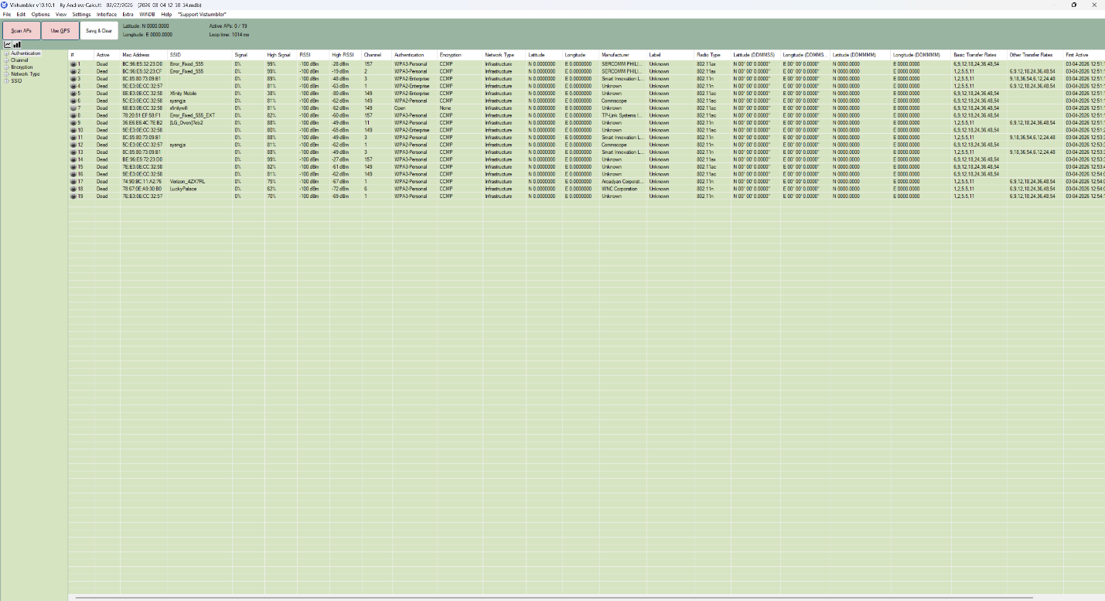
Appendix B: Detailed Network Log (CSV Export)
Description: This section contains the raw data exported from Vistumbler into a CSV format. This log provides the technical "fine print" for the 19 detected networks, including the BSSID (MAC addresses), the hardware manufacturer (such as Sercomm or TP-Link), and the specific signal strength measured in dBm.
# | SSID | BSSID (MAC Address) | Manufacturer | Signal Strength | Authentication | Encryption
1 | Error_Fixed_555 | BC:96:E5:32:23:D0 | SERCOMM PHILIPPINES INC | 99% (-28 dBm) | WPA3-Personal | CCMP
2 | Error_Fixed_555 | BC:96:E5:32:23:CF | SERCOMM PHILIPPINES INC | 99% (-19 dBm) | WPA3-Personal | CCMP
3 | (Hidden) | 8C:85:80:73:09:B1 | Smart Innovation LLC | 89% (-48 dBm) | WPA2-Enterprise | CCMP
4 | (Hidden) | 9E:E3:0E:CC:32:57 | Unknown | 81% (-63 dBm) | WPA2-Enterprise | CCMP
5 | Xfinity Mobile | 8E:E3:0E:CC:32:58 | Unknown | 38% (-80 dBm) | WPA2-Enterprise | CCMP
6 | syanga | 5C:E3:0E:CC:32:50 | Unknown | 81% (-63 dBm) | WPA2-Personal | CCMP
7 | xfinitywifi | 5E:E3:0E:CC:32:51 | Unknown | 40% (-79 dBm) | Open | None
8 | bms_guest_2.4_EXT | 78:29:ED:60:5B:E7 | TP-Link Systems | 85% (-52 dBm) | WPA2-Personal | CCMP
9 | DG_Guest2467 | DE:F0:F1:6C:FB:52 | Unknown | 89% (-40 dBm) | WPA2-Personal | CCMP
10 | (Hidden) | 8E:E3:0E:CC:32:50 | Unknown | 81% (-63 dBm) | WPA2-Enterprise | CCMP
11 | (Hidden) | 8C:85:80:73:00:01 | Smart Innovation LLC | 89% (-48 dBm) | WPA2-Enterprise | CCMP
12 | ivanga | 5C:E3:0E:CC:32:55 | Unknown | 81% (-63 dBm) | WPA2-Personal | CCMP
13 | (Hidden) | 8E:E3:0E:CC:32:55 | Unknown | 81% (-63 dBm) | WPA2-Enterprise | CCMP
14 | (Hidden) | 9E:E3:0E:CC:32:50 | Unknown | 81% (-63 dBm) | WPA2-Enterprise | CCMP
15 | (Hidden) | 9E:E3:0E:CC:32:55 | Unknown | 81% (-63 dBm) | WPA2-Enterprise | CCMP
16 | (Hidden) | 8C:85:80:73:00:05 | Smart Innovation LLC | 89% (-48 dBm) | WPA2-Enterprise | CCMP
17 | Verizon_4ZK7AL | 74:B0:BC:11:A2:F5 | Arcadyan Corp. | 81% (-63 dBm) | WPA2-Personal | CCMP
18 | Lucky_Home | 38:D2:69:A0:8E:90 | WNC Corporation | 70% (-69 dBm) | WPA3-Personal | CCMP
19 | (Hidden) | 7E:F3:0F:CC:32:57 | Unknown | 81% (-63 dBm) | WPA2-Personal | CCMP

